

SIMATS ENGINEERING
SAVEETHA INSTITUTE OF MEDICAL AND TECHNICAL SCIENCES
CHENNAI - 602105
PROJECT
Smart Urban Flood Prediction and
Emergency Response Platform

CSA-1012 Software Engineering

BACHELOR OF ENGINEERING
In
Computer Science Engineering

Submitted by
Y. Praveen Raj (192372306)

Under the Supervision of
Dr. K. Anita Davamani

July 2026

Abstract
Rapid, unplanned urbanization combined with climate change and ageing drainage infrastructure has made flash flooding a recurring threat to Indian and global cities alike. Existing flood-management practice is largely reactive: it depends on generic weather forecasts and manually reported waterlogging incidents, resulting in delayed evacuation, poor resource allocation, and avoidable loss of life and property.
This proposal presents the design of a distributed Smart Urban Flood Prediction and Emergency Response Platform that fuses IoT sensor networks, weather and GIS data, and machine-learning based predictive analytics into a single real-time situational-awareness system. The platform continuously senses rainfall, water level and drainage flow; forecasts flood risk at a hyper-local level; automatically alerts citizens and emergency responders; recommends safe evacuation routes; and generates analytics for municipal disaster-management authorities.
The system is architected as a scalable, fault-tolerant, multi-tenant platform capable of serving multiple cities simultaneously, ensuring the platform remains available precisely when the underlying infrastructure is most likely to be stressed by the flood event itself.
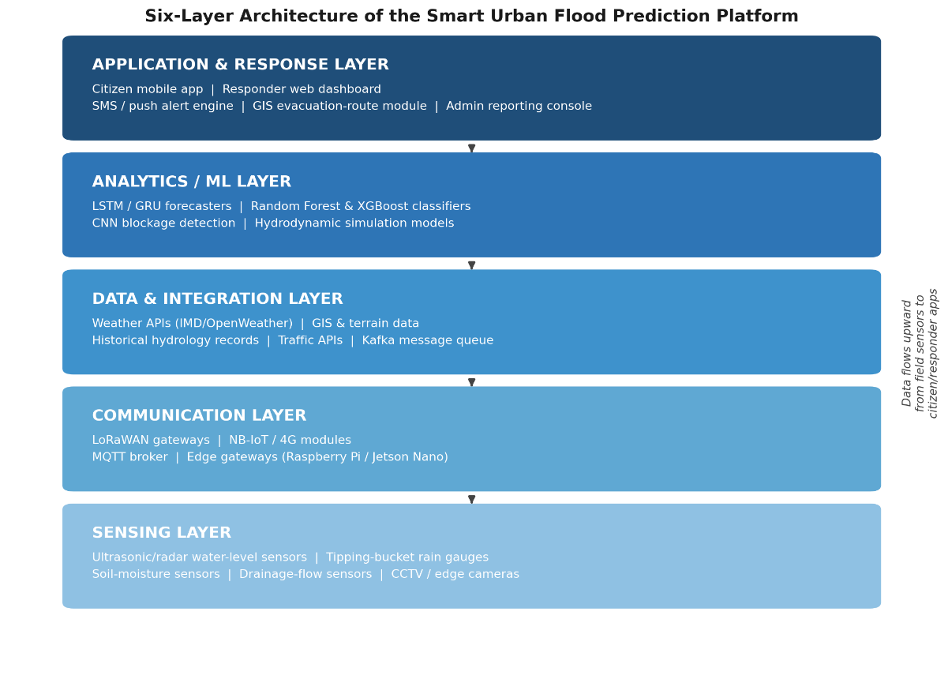

Table of Contents
Abstract 2
1. Industry Context 5
2. Problem Statement 5
3. Objectives 6
4. Related Work and Research Basis 6
5. Proposed System Architecture 7
6. Machine-Learning Methodology 9
7. Technology Stack 10
8. Core Platform Modules 10
9. Implementation Roadmap 11
10. Scalability, Reliability and Security Considerations 12
11. Testing, Validation and Risk Assessment 13
12. Expected Outcomes 14
13. Anticipated Challenges and Mitigation 14
14. Future Scope 14
15. Conclusion 15
16. References 15

List of Figures and Tables
Figures
Figure 1: Six-layer system architecture 8
Figure 2: End-to-end data flow, sensor to alert 9
Figure 3: Machine-learning task pipeline 9
Figure 4: Multi-city fault-tolerant deployment topology 12
Tables
Table 1: Layered system architecture 7
Table 2: ML models mapped to platform tasks 9
Table 3: Technology stack by category 10
Table 4: Phase-wise implementation roadmap 11
Table 5: Qualitative risk assessment matrix 13

1. Industry Context
Urban flooding has emerged as one of the most costly and frequent natural-hazard events worldwide. Rapid urbanization replaces natural absorptive land cover with impervious concrete surfaces, while climate change intensifies short-duration, high-intensity rainfall events that overwhelm storm-water drainage systems designed decades ago for lower rainfall thresholds. The result is repeated waterlogging, traffic gridlock, damage to property and critical infrastructure, and direct threats to public safety and life.
Municipal emergency-response agencies today largely depend on delayed manual field reports, citizen phone calls, and coarse-grained regional weather forecasts rather than hyper-local, sensor-verified flood intelligence. This creates a critical information gap between the moment a drainage system begins to fail and the moment responders are actually deployed — a gap during which water levels can rise from ankle-deep to life-threatening. Commercial and government flood-monitoring systems in most cities remain limited to river-gauge telemetry or generic rainfall forecasts; they rarely provide street-level, real-time visibility into storm-drain capacity, blockage status, or hyper-local inundation risk.
Recent research reflects a clear industry shift toward addressing this gap through the convergence of three technology trends:
- Low-cost IoT sensor networks (ultrasonic/radar water-level sensors, LoRaWAN connectivity) that make dense, real-time environmental monitoring economically viable at city scale.
- Deep-learning time-series models such as LSTM and GRU networks, which outperform traditional physics-based numerical models in multi-step-ahead flood forecasting because of their ability to learn complex temporal rainfall-runoff patterns directly from data.
- GIS-integrated decision-support tools that translate raw predictions into actionable, spatially-referenced guidance such as risk maps and evacuation routes.
There is therefore a clear and growing market and civic need for an integrated, intelligent platform that moves flood management from reactive, manual response to proactive, data-driven, real-time situational awareness — supporting smart-city initiatives, disaster-management authorities, and citizen safety simultaneously.

2. Problem Statement
Design and develop a distributed Smart Urban Flood Prediction and Emergency Response Platform that continuously monitors rainfall, water levels, drainage conditions, weather forecasts, and traffic conditions using IoT sensors, weather APIs, and GIS technologies.
The platform must ingest real-time environmental data from rivers, storm drains, reservoirs, and urban drainage systems. Using predictive analytics and machine-learning models, the system should forecast flood risks, identify vulnerable locations, notify emergency responders and citizens immediately, recommend evacuation routes, and generate disaster-management reports for municipal authorities.
The solution must support multiple cities simultaneously while ensuring horizontal scalability, fault tolerance, secure end-to-end communication, and high system availability — since the platform's usefulness is directly tied to its reliability during the exact moments when underlying network and power infrastructure is most likely to be stressed by the flood event itself.

2.1 Key Challenges Addressed
- Sparse and delayed ground-truth data on real-time drainage capacity and water levels.
- Generic, city-wide weather forecasts that fail to capture hyper-local flood risk at street or ward level.
- Manual, slow identification of drainage blockages that are a leading cause of flash flooding.
- Lack of automated, targeted early-warning and evacuation guidance for citizens in at-risk zones.
- Fragmented coordination between sensor data, weather services, GIS systems and emergency responders.
- Need for a system architecture that remains available and fault-tolerant under the network stress that floods themselves cause.

3. Objectives
The platform is designed around eight core objectives that together move flood management from reactive to proactive:
- Continuously monitor rainfall intensity and water levels across rivers, drains and reservoirs using a distributed IoT sensor network.
- Predict urban flooding before critical conditions occur, using time-series machine-learning models trained on historical and real-time hydrological data.
- Automatically detect drainage blockages using computer-vision and sensor-fusion techniques.
- Provide real-time, hyper-local flood alerts to citizens and emergency responders via SMS, push notification and dashboard.
- Recommend safe, dynamically updated evacuation routes using GIS and live traffic data.
- Support emergency-response coordination through a unified responder dashboard with live risk maps.
- Generate flood-risk analytics and historical disaster-management reports for municipal planning.
- Improve overall disaster preparedness and reduce response latency for city administrations.

4. Related Work and Research Basis
The proposed platform builds on an active and growing body of applied research at the intersection of IoT, hydrology and machine learning. Recent literature demonstrates that IoT sensor networks monitoring rainfall and water level in real time deliver markedly better prediction accuracy and faster emergency-response times than forecast-only approaches, since they provide direct, localized ground truth rather than relying solely on regional weather models.
On the prediction side, comparative studies evaluating classical machine-learning classifiers — including logistic regression, k-nearest neighbours, support vector machines, AdaBoost and Random Forest — consistently find ensemble tree-based methods such as Random Forest to be strong, interpretable performers for binary and multi-class flood-risk classification from meteorological and hydrological features. For sequential, time-dependent forecasting, deep-learning architectures such as LSTM and Gated Recurrent Unit networks have been shown to improve multi-step-ahead prediction accuracy over both traditional machine learning and purely numerical hydrodynamic models, owing to their ability to learn long-range temporal dependencies directly from rainfall and flood datasets.
Edge-computing deployments further show that LoRa-based sensor nodes placed directly in roadside drains and low-lying urban locations can capture hyper-local hydrological and meteorological parameters that coarse weather APIs miss entirely, while onboard edge inference (e.g., on Raspberry Pi devices) enables low-latency rainfall classification even when backhaul connectivity is degraded — a critical property during flood events. Complementary computer-vision research demonstrates that convolutional neural networks trained on drainage-canal imagery can automatically detect blockages and debris accumulation, addressing one of the leading and most preventable causes of flash flooding in dense urban catchments.
Collectively, this research base validates the core technical premise of the proposed platform: that fusing dense IoT ground-truth sensing, GIS-referenced terrain and drainage data, and modern deep-learning forecasting models can materially outperform the forecast-only, manually-reported status quo in both prediction accuracy and response latency.

5. Proposed System Architecture
The platform is designed as a six-layer, loosely-coupled distributed system so that individual layers can scale, fail over, and be upgraded independently — a requirement given the multi-city, high-availability scope of the project.
Layer | Components | Function
Sensing Layer | Ultrasonic/radar water-level sensors, tipping-bucket rain gauges, soil-moisture sensors, drainage-flow sensors, CCTV/edge cameras | Continuously capture rainfall intensity, water depth, drain flow rate and visual blockage indicators at the source
Communication Layer | LoRaWAN gateways, NB-IoT/4G modules, MQTT broker, edge gateways (Raspberry Pi/Jetson Nano) | Transmit sensor readings from field nodes to the cloud with low power and long range; perform edge pre-filtering
Data & Integration Layer | Weather APIs (IMD/OpenWeather), GIS/terrain data, historical hydrology records, traffic APIs, message queue (Kafka) | Aggregate heterogeneous real-time and static data sources into a unified data lake
Analytics / ML Layer | LSTM/GRU time-series forecasters, Random Forest classifiers, CNN-based drain-blockage detection, hydrodynamic simulation models | Predict flood risk levels, forecast water-level rise, classify blockage severity, and identify vulnerable zones
Application & Response Layer | Citizen mobile app, responder web dashboard, SMS/push alert engine, GIS evacuation-route module, admin reporting console | Deliver early warnings, visualize risk maps, recommend evacuation routes, and coordinate emergency response
Table 1: Layered system architecture of the flood-prediction platform
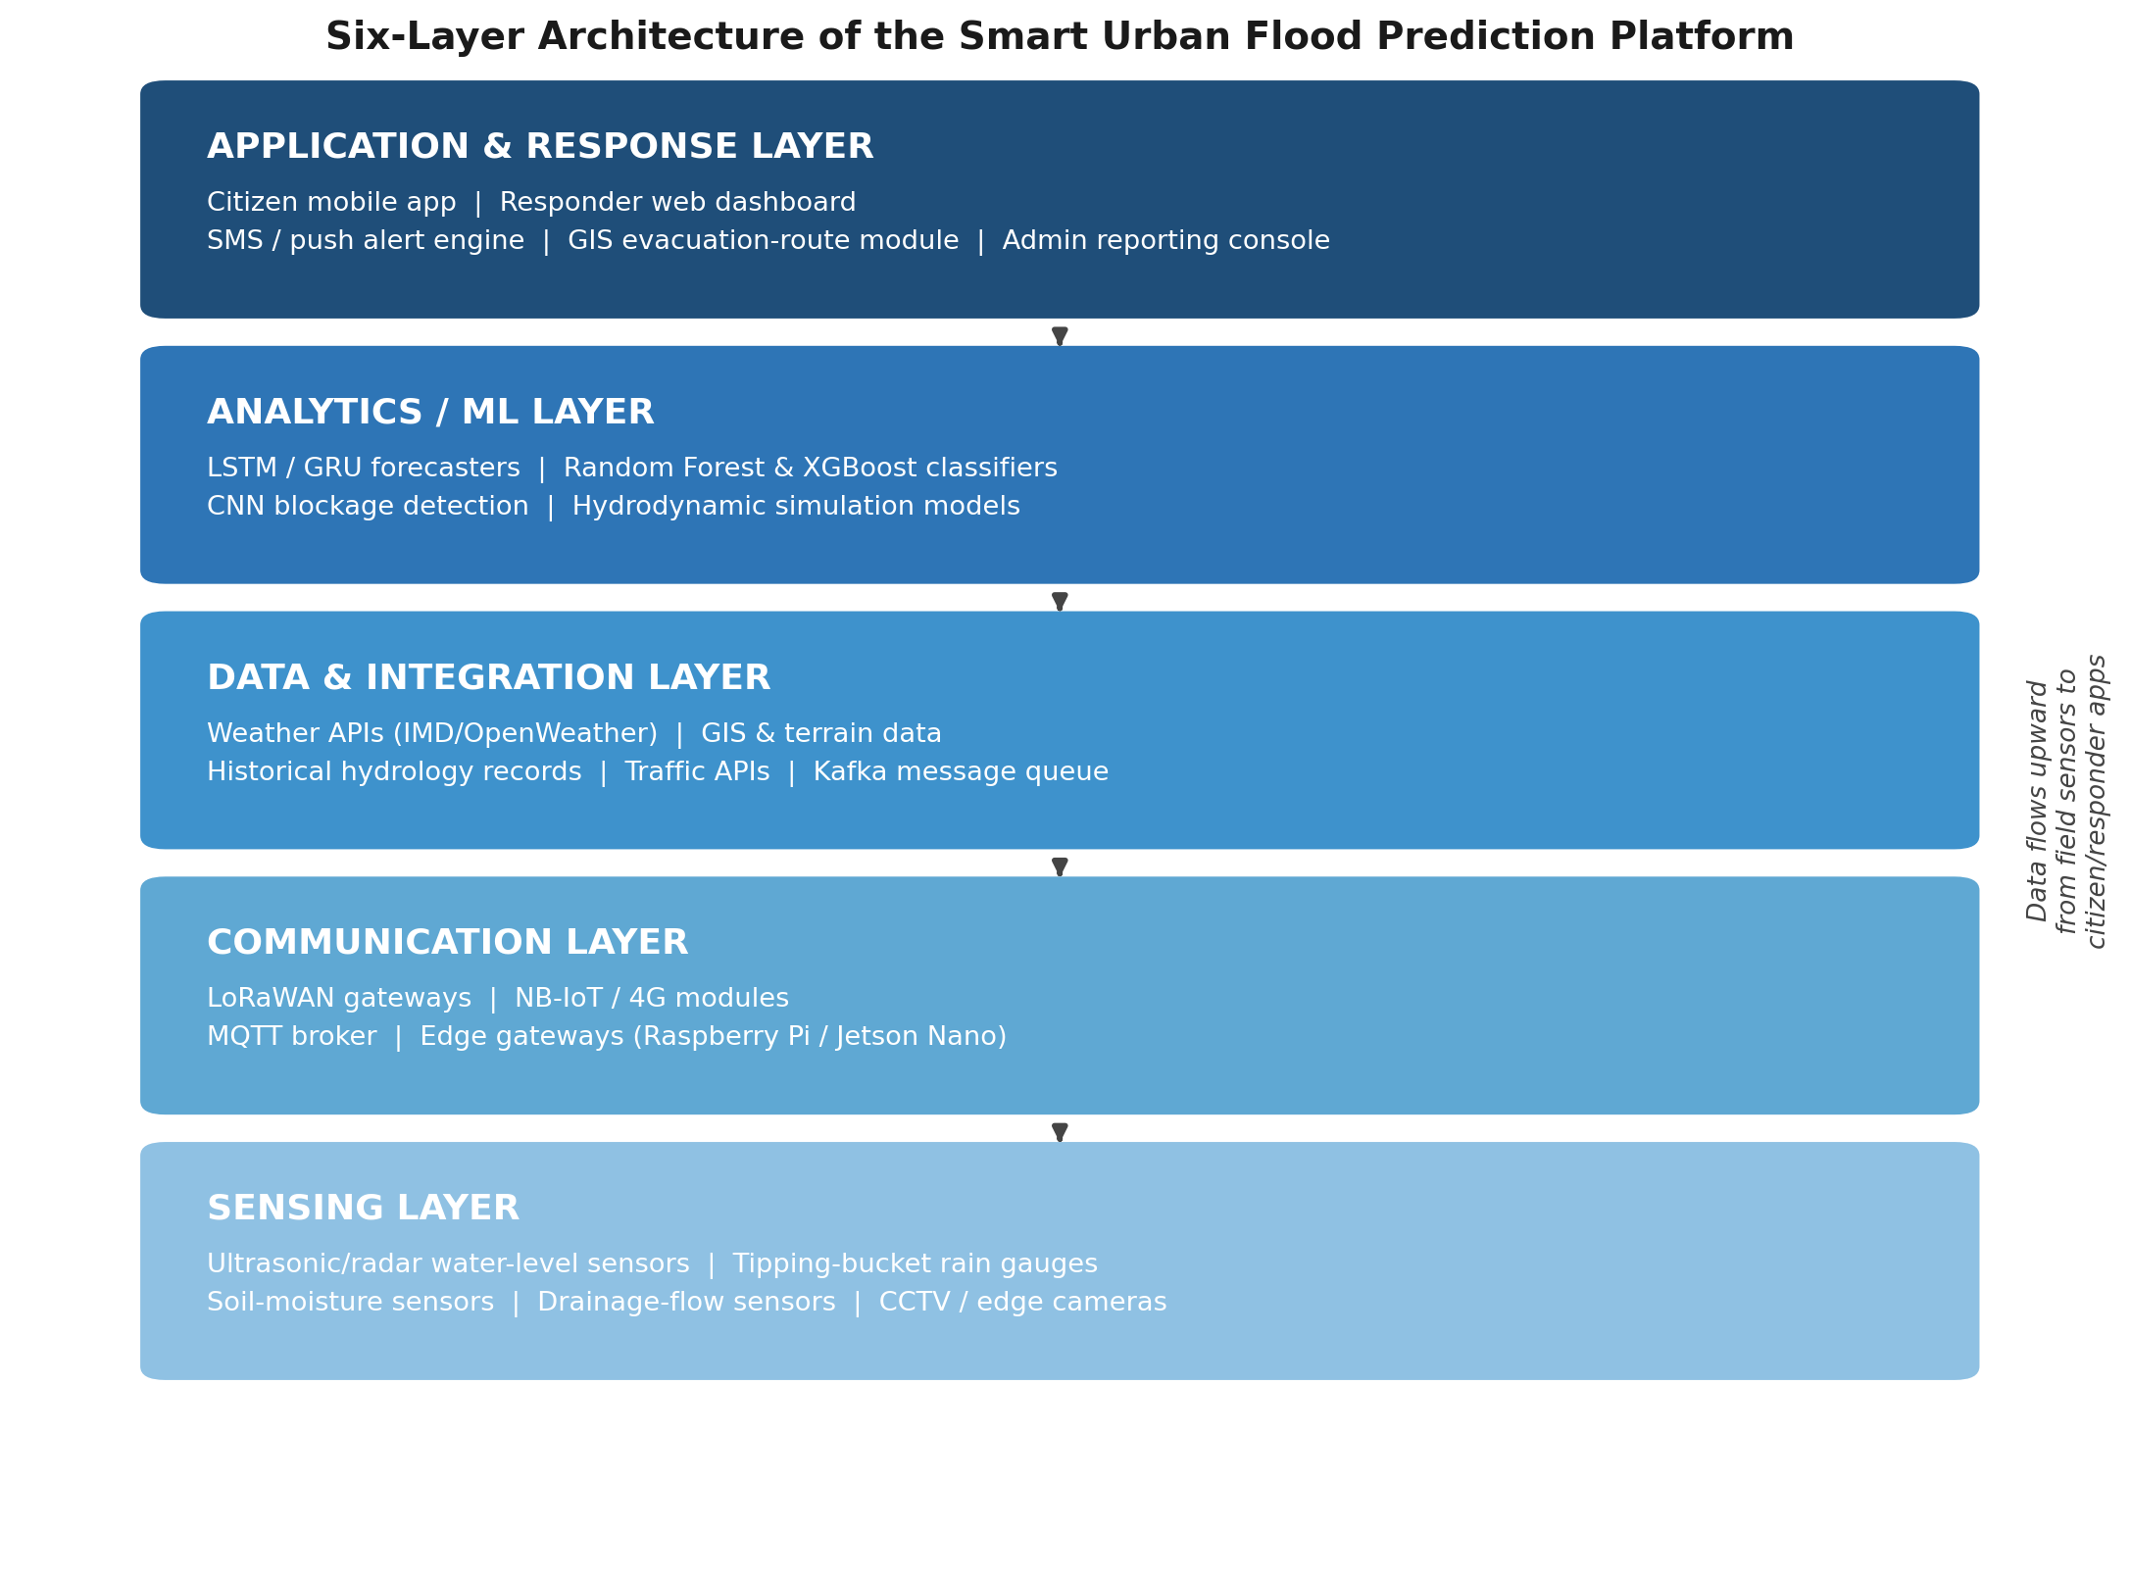
Figure 1: Visual representation of the six-layer architecture, showing bottom-up data flow from field sensors to citizen and responder applications

5.1 Data Flow Summary
Field sensors continuously stream rainfall, water-level and drain-flow readings to edge gateways over LoRaWAN/NB-IoT. Edge gateways perform lightweight filtering and forward data via MQTT to a cloud-based Kafka ingestion pipeline, where it is fused with weather-API forecasts, GIS terrain/drainage-network layers, and historical hydrology records.
The analytics layer runs trained LSTM/Random-Forest models on this fused stream to produce rolling flood-risk scores per monitored zone. When a risk score crosses a configurable threshold, the application layer automatically triggers citizen alerts, updates the responder dashboard's live risk map, and computes recommended evacuation routes — closing the loop from raw sensor reading to actionable guidance typically within seconds.
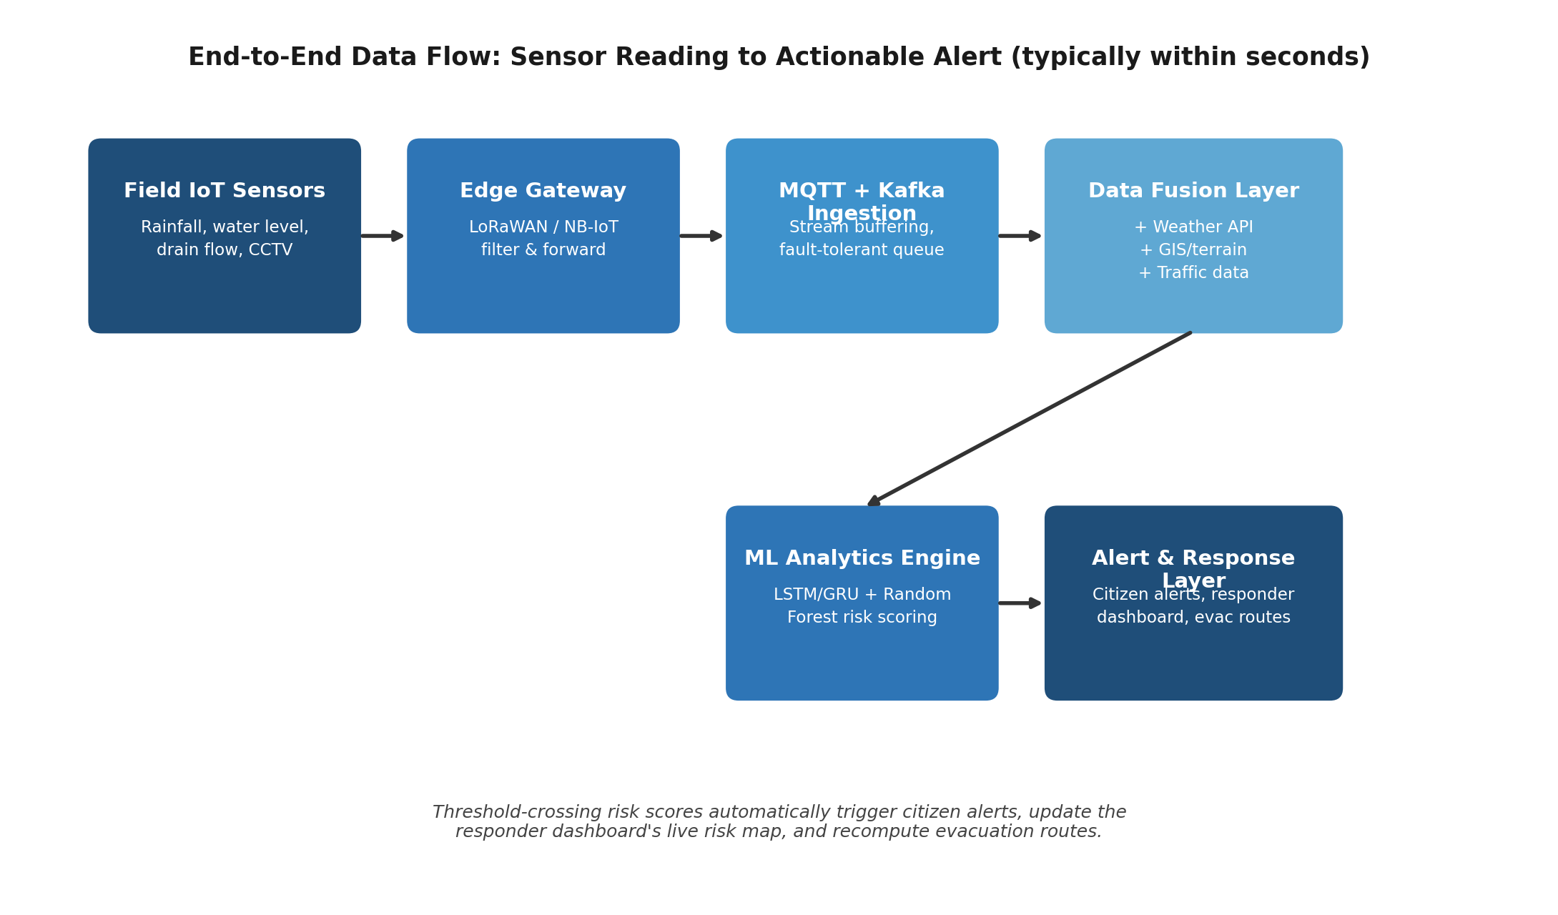
Figure 2: End-to-end data flow from sensor reading to actionable alert

6. Machine-Learning Methodology
Flood prediction is treated as a combination of a regression/forecasting problem (predicting water level or rainfall over the next N hours) and a classification problem (categorizing each monitored zone into low, medium or high flood-risk). The platform therefore uses a small ensemble of purpose-fit models rather than a single monolithic one, as summarized below.
Task | Model(s) | Rationale
Water-level / flood-stage forecasting | LSTM, GRU (deep learning time-series) | Captures long-range temporal dependencies in rainfall–runoff sequences, outperforming classical numerical models on multi-step-ahead prediction
Flood-risk classification (low/medium/high) | Random Forest, XGBoost | Handles nonlinear, heterogeneous tabular features (rainfall, terrain slope, drainage capacity) with strong accuracy and interpretability
Drainage-blockage detection | CNN on CCTV/edge-camera imagery | Automatically flags debris accumulation or obstruction in storm drains from visual data
Anomaly detection in sensor streams | Isolation Forest / Autoencoders | Identifies faulty sensors or unusual readings that could otherwise trigger false alarms
Spatial flood-extent mapping | GIS overlay + hydrodynamic simulation | Combines elevation (DEM) and drainage-network data with ML outputs to visualize vulnerable zones
Table 2: Machine-learning models mapped to platform tasks
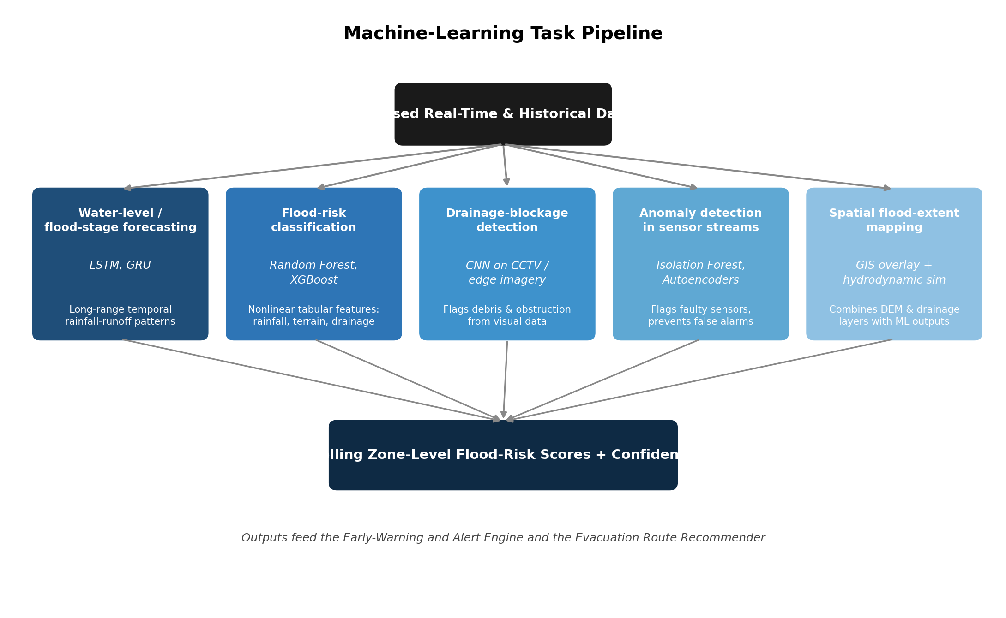
Figure 3: Machine-learning task pipeline from fused data to zone-level risk scores

6.1 Training Data Sources
- Historical rainfall, river-gauge and reservoir-level records from meteorological and municipal water-board archives.
- Live IoT sensor streams collected during the pilot deployment phase.
- Digital Elevation Model (DEM) and storm-drain network GIS layers for terrain-aware risk scoring.
- Past flood-incident and waterlogging-complaint records for ground-truth labelling.

6.2 Model Evaluation
Models are benchmarked using standard regression metrics (RMSE, MAE) for water-level forecasting and classification metrics (precision, recall, F1-score) for risk-level classification, with particular emphasis on recall for the “high-risk” class to minimize missed warnings. Models are retrained periodically as new labelled flood events accumulate, and a human-in-the-loop review process allows municipal disaster-management staff to flag false positives/negatives that feed back into retraining.

7. Technology Stack
The technology stack is chosen for proven reliability at city scale, strong open-source community support, and compatibility with a microservices deployment model.
Category | Technologies
IoT Hardware | Ultrasonic/radar water-level sensors, tipping-bucket rain gauges, DHT22 humidity-temperature sensors, ESP32/Arduino nodes, Raspberry Pi / NVIDIA Jetson edge devices
Connectivity | LoRaWAN, NB-IoT, MQTT, REST/GraphQL APIs, 4G/5G backhaul
Data Storage | Time-series database (InfluxDB/TimescaleDB), PostgreSQL + PostGIS for spatial data, cloud object storage (S3), Apache Kafka for streaming
Machine Learning | Python, TensorFlow/PyTorch, scikit-learn, LSTM/GRU for time-series forecasting, Random Forest & XGBoost for classification, OpenCV/CNN for image-based blockage detection
Backend | Microservices architecture (FastAPI/Node.js), Docker, Kubernetes for orchestration, containerized ML inference services
GIS & Mapping | QGIS/ArcGIS for terrain and floodplain modeling, Google Maps / OpenStreetMap APIs for evacuation routing
Frontend | React.js responder dashboard, Flutter/React Native citizen mobile app, Chart.js/D3.js for visualization
Cloud & DevOps | AWS/Azure/GCP, CI/CD pipelines, load balancers and auto-scaling for multi-city deployment
Security | TLS/SSL encrypted communication, OAuth2/JWT authentication, role-based access control, data anonymization for citizen privacy
Table 3: Proposed technology stack by category

8. Core Platform Modules

8.1 Environmental Monitoring Module
Aggregates live rainfall, water-level, and drainage-flow readings from the IoT sensor network into per-zone dashboards, with automatic sensor-health monitoring and anomaly flagging for faulty or offline nodes.

8.2 Flood Prediction Engine
Runs the LSTM/Random-Forest ensemble against streaming and historical data to produce rolling, zone-level flood-risk scores refreshed at short intervals, along with a confidence indicator for each prediction.

8.3 Drainage Blockage Detection
Uses edge-camera imagery and a CNN-based classifier to automatically detect obstructed or overflowing storm drains, prioritizing them for municipal maintenance crews and factoring blockage severity into the risk model.

8.4 Early-Warning and Alert Engine
Pushes targeted SMS, mobile-app and public-address alerts to citizens within a defined radius of a rising-risk zone, and escalates automatically to on-duty emergency responders and municipal control rooms when risk crosses critical thresholds.

8.5 Evacuation Route Recommender
Combines the live flood-risk map with real-time traffic and road-closure data to compute and continuously update the safest available evacuation routes, surfaced directly in the citizen mobile app and responder dashboard.

8.6 Emergency Response Coordination Dashboard
Gives municipal disaster-management teams a unified, map-based operational view — live sensor status, active alerts, responder locations, and resource-allocation tools — to coordinate multi-agency response in real time.

8.7 Analytics and Reporting
Generates historical flood-risk analytics, incident-response time reports, and post-event summaries to support long-term urban-planning and infrastructure-investment decisions.

9. Implementation Roadmap
The platform is intended for phased rollout rather than a single big-bang deployment, since both the sensor network and the machine-learning models benefit from an incremental, data-driven build-out. A phased approach also lets the project validate prediction accuracy and responder workflows on a small pilot zone before the operational and financial commitment of a multi-city rollout.
Phase | Duration | Key Activities | Milestone / Deliverable
Phase 1 — Pilot Setup | Months 1–4 | Finalize requirements with municipal stakeholders; deploy sensor nodes in 2–3 highest-risk wards of a single pilot city; establish the ingestion pipeline; begin baseline data collection | Instrumented pilot zone with live sensor telemetry flowing into the data lake
Phase 2 — Model Development | Months 4–8 | Train and validate LSTM/Random-Forest models on pilot data; integrate the CNN blockage-detection module; build the responder-dashboard MVP; run predictions in shadow mode alongside real events | Validated prediction models and a working dashboard, tested without live citizen alerts
Phase 3 — Live Deployment | Months 8–12 | Enable live citizen and responder alerts in the pilot city; introduce human-in-the-loop verification for high-severity alerts; tune risk thresholds using early field feedback | Fully operational platform in one city, generating verified real-time alerts
Phase 4 — Multi-City Scale-Up | Months 12+ | Onboard additional cities using Kubernetes auto-scaling; apply transfer learning for data-sparse cities; integrate with regional disaster-management authorities | Multi-tenant platform serving several cities on a shared architecture
Table 4: Indicative phase-wise implementation roadmap
Each phase gate is tied to a measurable exit criterion — for example, Phase 2 does not conclude until shadow-mode predictions meet the recall target defined in Section 6.2 — so that live citizen alerts are only enabled once model performance has been independently verified against real pilot-city events.

10. Scalability, Reliability and Security Considerations
- Scalability: Microservices deployed on Kubernetes with horizontal auto-scaling allow the platform to onboard additional cities by adding new sensor-ingestion and analytics pods without redesigning core services.
- Fault tolerance: Message queuing (Kafka/MQTT) with persistent buffering ensures sensor data is not lost during connectivity interruptions, which are common during severe weather; edge gateways cache and forward on reconnect.
- High availability: Multi-zone cloud deployment with load balancing and automated failover, since the system is most critical exactly when local infrastructure is under the most stress.
- Secure communication: End-to-end TLS/SSL encryption, OAuth2/JWT-based authentication for all APIs, and role-based access control separating citizen, responder and administrator privileges.
- Data privacy: Citizen location data used for targeted alerts is anonymized and retained only as long as operationally necessary, in line with data-protection best practice.
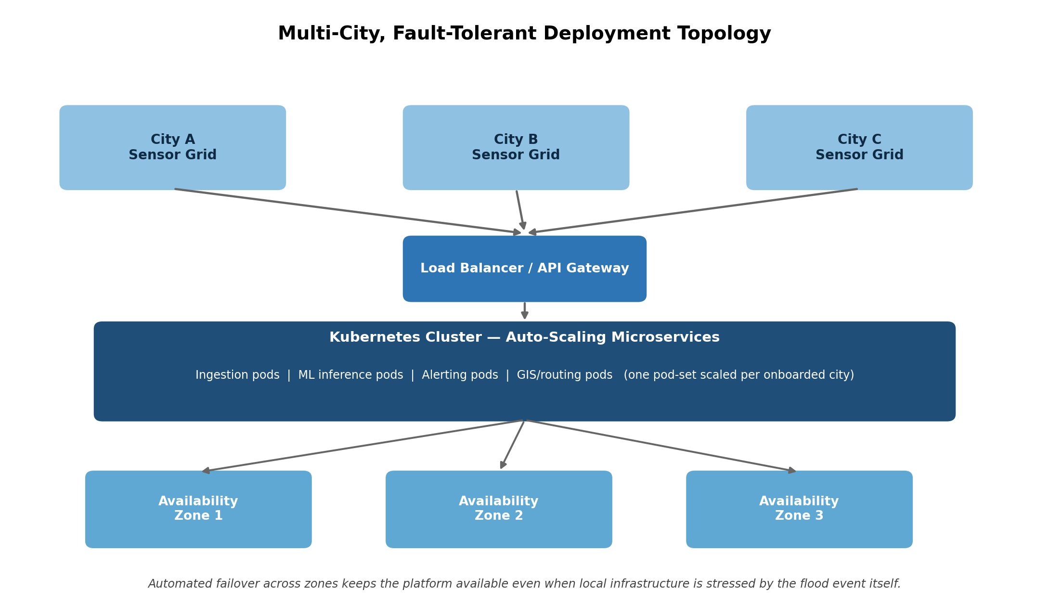
Figure 4: Multi-city, fault-tolerant deployment topology on a Kubernetes-orchestrated cloud

11. Testing, Validation and Risk Assessment
Because the platform's value depends entirely on being correct and available at the moment of a flood event, testing spans four layers: infrastructure, data pipeline, model, and end-to-end response workflow.
- Unit and integration testing of each microservice (ingestion, analytics, alerting, GIS routing) in isolation and as a connected pipeline.
- Load testing of the MQTT/Kafka ingestion layer under simulated flood-event traffic spikes, since sensor reporting frequency and volume both rise sharply during actual storms.
- Model validation using k-fold cross-validation on historical data and holdout testing against past flood events not seen during training, with recall on the high-risk class tracked as the primary acceptance metric.
- Fault-injection (chaos-style) testing that deliberately disconnects edge gateways and cloud availability zones to verify that buffering, store-and-forward, and automated failover behave as designed.
- Field pilot validation comparing sensor-verified predictions against real, on-the-ground waterlogging reports before any phase is allowed to progress to full live alerting.
The table below summarizes the principal project risks identified in Section 12, with a qualitative likelihood/impact assessment used to prioritize mitigation effort.
Risk | Likelihood | Impact | Mitigation
Sensor deployment cost and maintenance in dense urban areas | Medium | Medium | Low-cost sensor nodes; phased rollout starting with highest-risk zones
Data sparsity for ML training in low-history cities | Medium | High | Transfer learning from data-rich pilot cities; simulation-augmented training data
Network disruption during severe weather | High | High | LoRaWAN long-range low-power links; edge-level buffering and store-and-forward
False positives eroding citizen trust | Medium | High | Human-in-the-loop verification for high-severity alerts; continuous retraining on feedback
Inter-agency coordination gaps | Medium | Medium | Shared role-based dashboard co-designed with disaster-management stakeholders
Table 5: Qualitative risk assessment matrix

12. Expected Outcomes
- Reduce flood-related property and infrastructure damages through earlier, more accurate warnings.
- Improve public safety by giving citizens timely, hyper-local alerts and safe evacuation guidance.
- Enable faster emergency response through automated, prioritized alerts to responders and control rooms.
- Improve municipal disaster management with a unified, real-time operational dashboard.
- Reduce traffic disruption by rerouting citizens away from waterlogged and flood-prone roads in real time.
- Enhance environmental monitoring through continuous, city-wide rainfall and water-level data collection.
- Increase citizen awareness and preparedness through accessible mobile-app alerts and risk visualization.
- Support scalable smart-city deployment across multiple cities using a common, multi-tenant platform architecture.

13. Anticipated Challenges and Mitigation
- Sensor deployment cost and maintenance in dense urban environments — mitigated by prioritizing low-cost sensor nodes and phased rollout starting with the highest-risk zones identified through historical flood data.
- Data sparsity for training ML models in cities with limited historical flood records — mitigated by transfer learning from data-rich pilot cities and synthetic/hydrodynamic-simulation-augmented training data.
- Network reliability during severe weather — mitigated through LoRaWAN's long-range low-power characteristics and edge-level buffering.
- False positives eroding citizen trust in alerts — mitigated through a human-in-the-loop verification step for high-severity alerts and continuous model retraining on responder feedback.
- Inter-agency coordination across municipal departments — mitigated by a shared, role-based dashboard designed collaboratively with disaster-management stakeholders during Phase 1.

14. Future Scope
- Integration with satellite-based SAR (Synthetic Aperture Radar) imagery for large-scale flood-extent mapping during major events.
- Incorporation of physics-informed neural networks that combine hydrodynamic simulation with data-driven learning for improved accuracy in data-scarce areas.
- Extension to a national or regional multi-city flood-intelligence network with cross-city model sharing.
- Integration with smart-city traffic-signal control to proactively reroute traffic away from predicted flood zones before waterlogging occurs.
- Citizen-reporting crowdsourcing layer to supplement sensor data with geotagged photo reports, verified through the CNN blockage-detection pipeline.

15. Conclusion
The Smart Urban Flood Prediction and Emergency Response Platform addresses a well-documented and worsening gap between generic weather forecasting and the hyper-local, real-time flood intelligence that modern cities need. By combining a distributed IoT sensor network, GIS-referenced spatial data, and a purpose-built ensemble of machine-learning models within a scalable, fault-tolerant microservices architecture, the platform is designed to move urban flood management from reactive and manual to proactive and data-driven — reducing response latency, protecting life and property, and supporting long-term, evidence-based urban-infrastructure planning across multiple cities.

16. References
Anik, M.S.B.M. & An, C. (2025). Evolution from the physical process-based approaches to machine learning approaches to predicting urban floods: a literature review. Environmental Systems Research, 14(1), 15.
Bukhari, S.A.S., Shafi, I., Ahmad, J. et al. (2025). Enhancing flood monitoring and prevention using machine learning and IoT integration. Natural Hazards, 121, 4837–4864.
Nezhadbasaidu, S., Gheisari, M., Kheyrkhah, A. et al. (2025). A flood expert system using machine learning and IoT: warning, detection, and prediction. International Journal of System Assurance Engineering and Management, 16, 1106–1122.
Rizal, H.M., Hariadi, M., Arif, Y.M., & Warni, E. (2025). Enhancing Flood Prediction in Urban Areas: A Machine Learning Approach for Makassar City. Engineering, Technology & Applied Science Research, 15(2), 21678–21684.
Kubra, A., Lokesh, K.J., Shakthi, G. et al. (2025). Enhanced Flood Prediction and Management for Urban Underpass Using Machine Learning. Proceedings of the Sixth International Conference on Computer and Communication Technologies (IC3T 2024), Lecture Notes in Networks and Systems, vol. 1356. Springer, Singapore.
International Journal of Advanced Computer Science and Applications (2025). Edge-Integrated IoT and Computer Vision Framework for Urban Flood Monitoring, Vol. 16, No. 9.
Motta, M., de Castro Neto, M., & Sarmento, P. (2021). A mixed approach for urban flood prediction using machine learning and GIS. International Journal of Disaster Risk Reduction, 56, 102154.

